Dominic Drury

10/24/2023

CS-340

1-3 Assignment: Intro to MongoDB

Screenshot of executed mongo shell

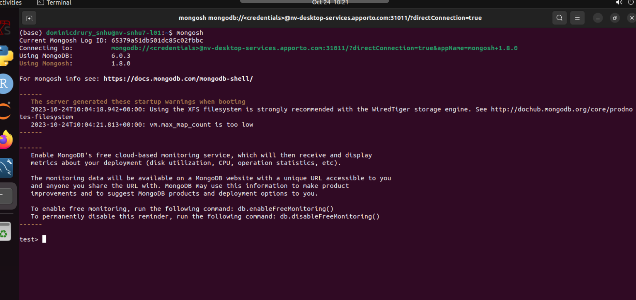

Screenshots of retrieving a document from the collection

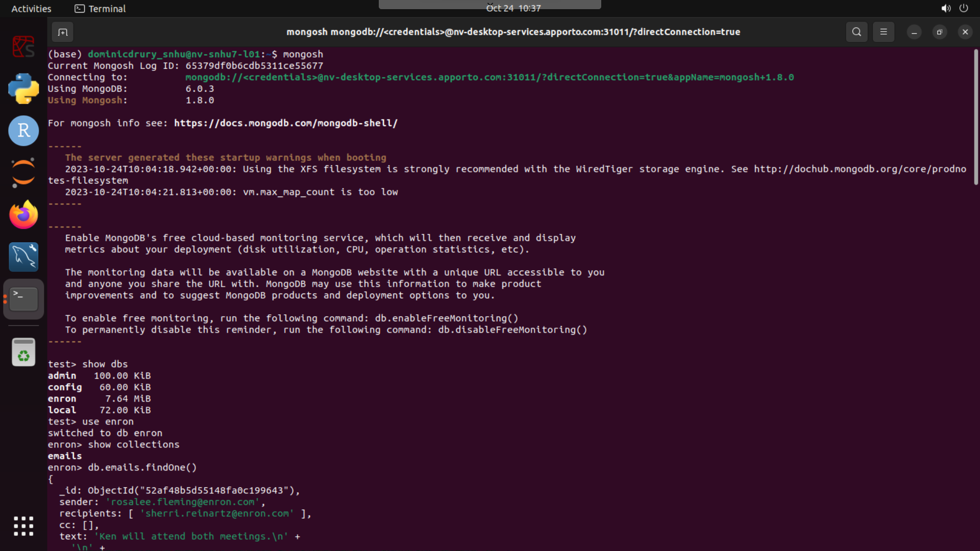

Screenshot of size of a single document

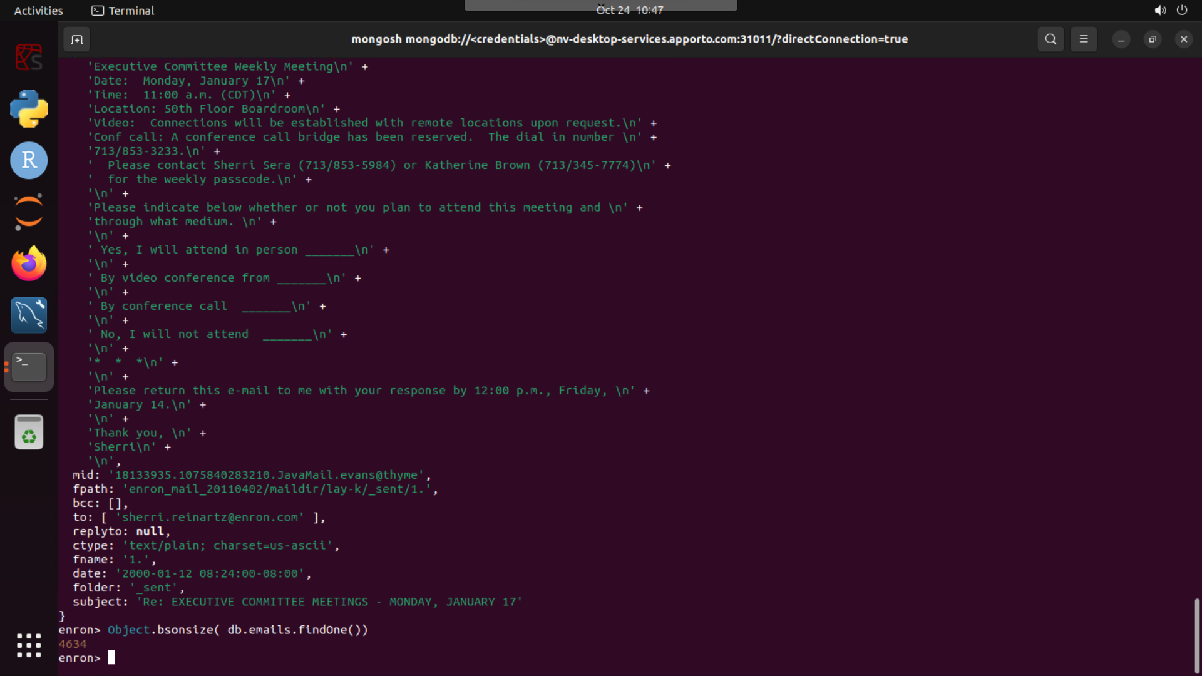

Screenshot of the size of the collection of documents

